**REPORT ON YOUTUBE VIDEO YOUTUBE DOWNLOADER** **USING PYTHON**

As a Project for Course

**PYTHON PROGRAMMING (INT 213)**

**Name :** Trishanth Surla

**Registration Number :** 12011637

**Name :** Oblisetti Jitendra Sai

**Registration Number :** 12007386

**Program :** CSE B.Tech (HONS).

**Semester :** Second Semester

**School :** School of Computer Science

**Name of the University :** Lovely Professional University

**Date of Submission :** 30th November 2022

*********************************************



**YOUTUBE VIDEO DOWNLOADER**

**Abstract**

First of all Youtube is a largest online video sharing platform.There were lot of videos we wish we could have watched without of internet on our Laptops or Desktops.

Well here is a solution where we can download any type of youtube video just within our Laptop’s.

In this project we build a GUI Based Youtube Video Downloader using the **Tkinter** and **Pytube** modules of python.

**Context**

This project was done as part of my course for the CSE(H) at Lovely Professional University.

**Introduction of the Project**

The Youtube Video Downloader aims at downloading any type of video from Youtube in a fast,simple and easy way.

The user has to copy the youtube video URL link which needs to be pasted in the application.Later the user needs to enter file location where the file is going to be downoaded and also name of the file.

**Libraries/Modules**

For this project we imported two modules

**Tkinter**

**Pytube**

**Tkinter**

This is a famous library in the python app development world. The **GUI** (Graphics User Interface**)**. There is no need to install the same. The library is used to build the GUI based applications for Computers. Python when Combined with Tkinter provides a fast and easy way to create GUI Applications. Tkinter provides a powerful object-oriented interface to the Tk toolkit

**Pytube**

Pytube is a light weight, Dependency-free python library which is used for downloading videos from the Web. Pytube is not the native library. We need to install it before using it.

The installation of any Python Package is made easier with the help of python package manager PIP.

Shown in the following command

**pip install pytube**

**Project File Structure**

There were three main steps where we executed to build this Python Youtube Video Downloader

**Import all the Necessary Modules**

**Creating the Download and Reset Functions**

**Initializing the Window and Placing all its components**

**Importing all the Necessary Modules**

For this project we will be importing two Libraries namely **Tkinter** and **Pytube** where Pytube module is used to handle operations related to Youtube

**Creating the Download and Reset Functions**

The **download()** function was built to leverage the Youtube class to download Youtube videos.

The function will be given three parameters.

All of these should be Entry objects with StringVar objects controlling them. Then we'll retrieve the test from the Entry objects and assign it to variables for the first time.

Then, when we start the YouTube class, we'll utilise the try except statements to ensure that the user has access to the internet in order to download the required video; otherwise, an error message will be printed.

In **reset()** function,we will set the 3 StringVar objects that are provided as arguments,that control the 3 Entry objects, as blank strings so the values in Entry objects also become blank.

**Initializing the Window and Placing all its components**

Here we used the **Tk()** class to initialize the **GUI** Window

* The **.title()** method is used to specify the initial geometry of the Window.
* The**.geometry()** function is used to specify the window's initial geometry..
* • The **.resizeable()** function is used to provide or deny the ability to resize the window. It accepts two arguments: truthy and false values. Its positional arguments have the form of Width and Height.
* The .**configure()** method is used to specify the Tk class's additional characteristics, such as bg, which sets the window's background colour.
* The **.update()**  and **.mainloop()** methods are used to create a loop in the window so that it does not shut as soon as it opens.

The **Label** class is used to add static text to the window.Its parameters and methods are:

* The **Master** parameter,the positional argument root in this case, is the parent widget it is associated with.
* The **Text**  parameter is the text that will be displayed on the widget.
* The **Font** parameters is the font family and size and text eggects of the text in the widget.

The **Button**  class is used to add a button to the window that runs a function when pressed.Its parameters and methods are:

* The **Command**  parameter defines the function that will run when the button is pressed.

The **Entry** class is used to add an input field to a window so that the user may enter data.Its methods are

* The **Width** parameter is used to specify the maximum amount of characters that can be accommodated by the widget.
* The **.get()** method is used to get the text inputted by the user in the Entry widget. It takes no arguments

The **StringVar** In Label and Entry widgets, class is used to alter text.Its methods are

* The **.set()** method is used to set a value to the StringVar object and the widget it manipulates. The only argument it takes is the text that the value has to be set to.

The **.Place()** method, which is one of the Three Tkinter geometry manager methods,positions a widget such that it is placed on a Cartesian plane.

* The x,y parameters represent the widget's horizontal and vertical offsets, respectively.
* The **relx**,**rely** parameters are the horizontal and vertical offsets of the widget in terms of a floating number between 0.0 and 1.0
* The **Anchor** parameters specifies the window's corner or side that will be used as the origin of the cartesian plane in which our window will be placed.

**Screenshots**

**1.Main page**

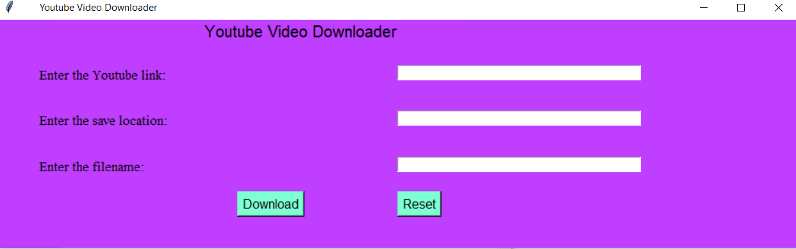

**2.Copying the Youtube Link**

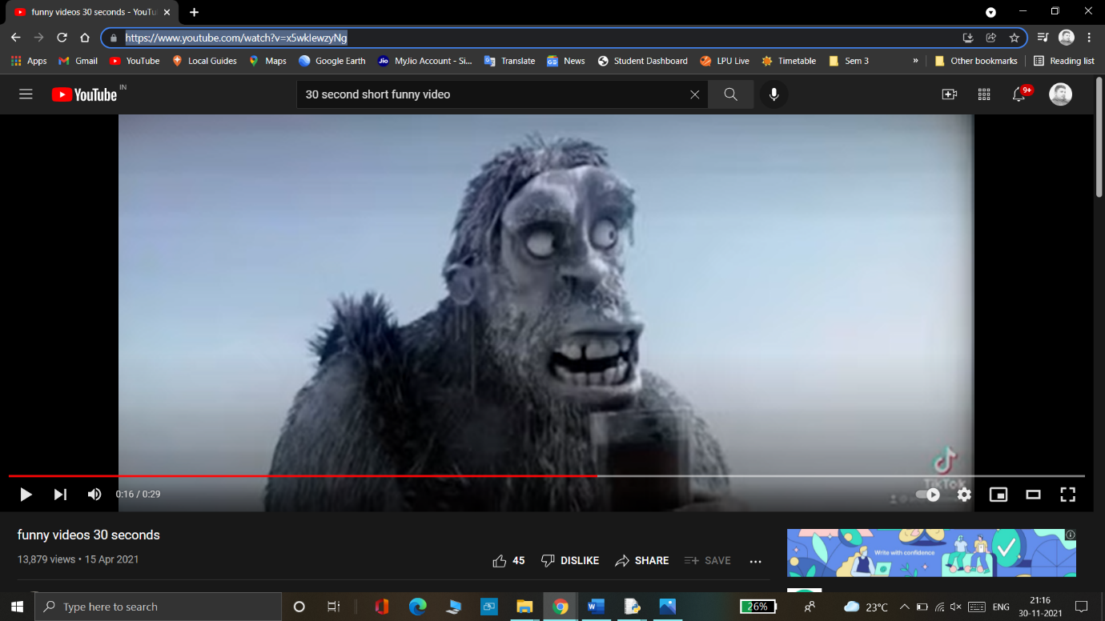

**3.Pasting the Youtube link in the page**

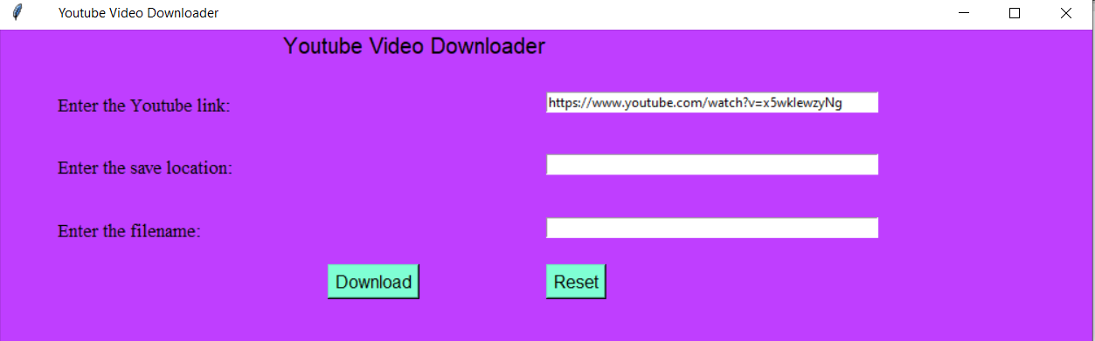

**4.Entering the File location to save the File**

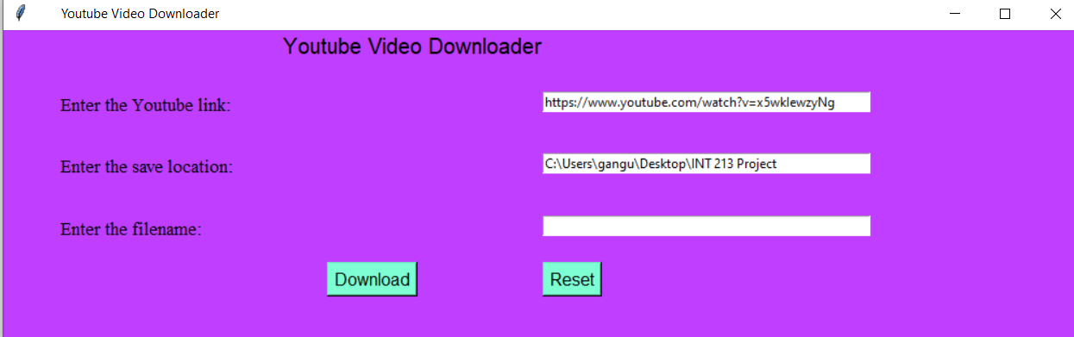

**5.Entering the File Name**

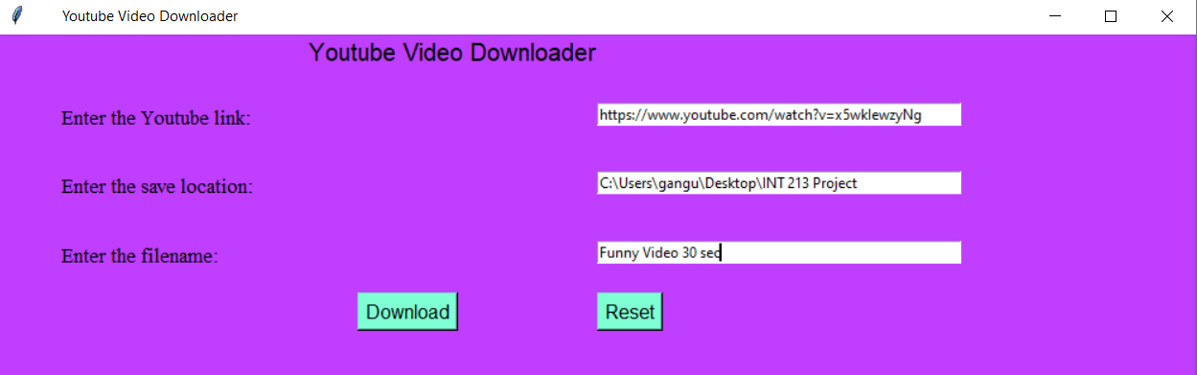

**6.Downloaded file the Entered Folder**

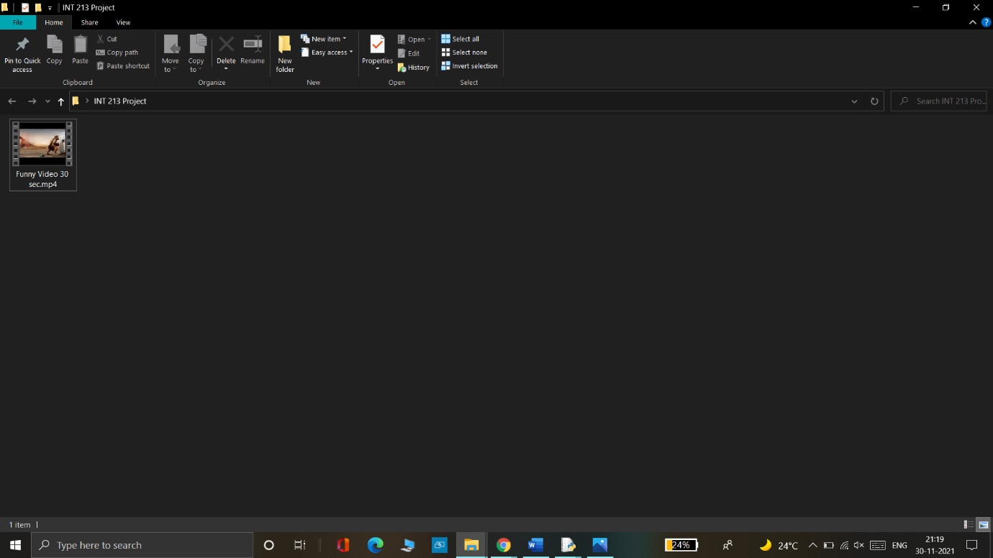

**7.Streaming the Offline Video**

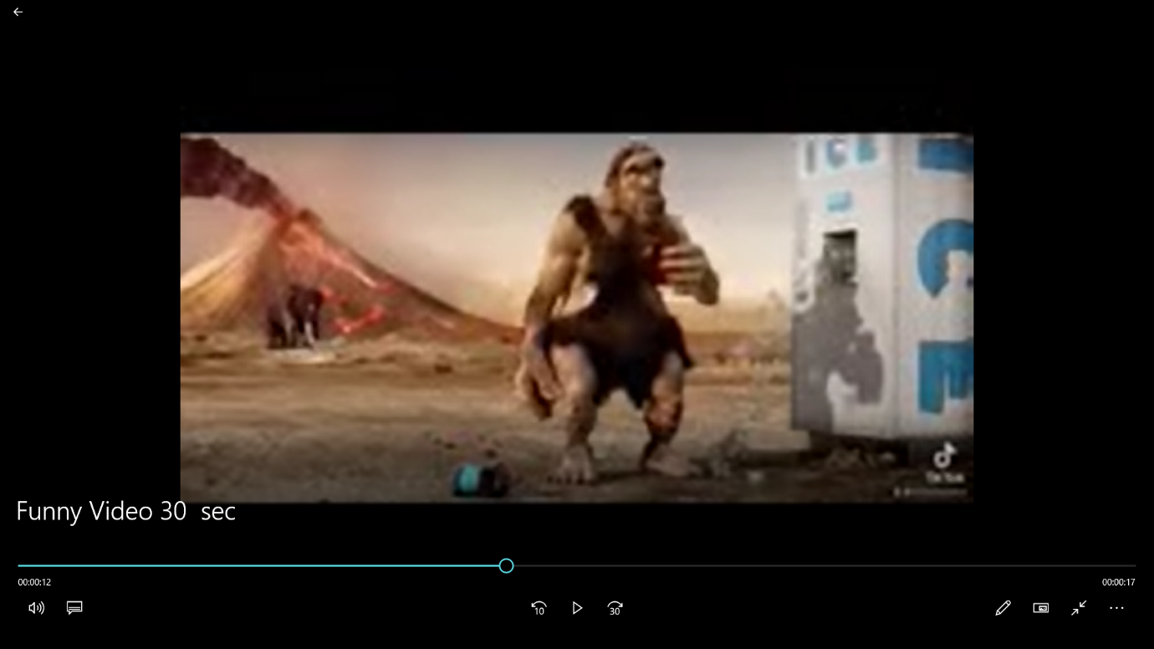

**Conclusion:**

Finally, we constructed our own GUI-based YouTube Video Downloader. We may now download YouTube videos directly to your laptop without any problems.

**THANK YOU**